CMPS115 Release Plan
Product Name: Tutor+
Team Name: Tutor Squad
Release Date: 2018-10-9
Revision Number: 1.0
Revision Date: 2018-10-9

Member
Project member: Vash Wang, Wenhao Ge, Yueting Wu, Xuelei Guo, Bo Lan
Project owner: Junyi Zhao

Introduction
Always, it's hard to understand what the professor is talking about and it doesn't help to ask for TAs either. In this case, tutors would be a good way to learn from. As you paid them, they have to be more responsible for your concerns. However, finding a good TA is not easy. Your money and time will still be wasted. Therefore, our solution is Tutor+, an IOS mobile app. We can have very specific options for the user such as what’s your class and what’s the content of your class. It would be more convincing if someone has already taken the same class and got an A to become your tutor rather than to find someone randomly. Tutor+ enables you to find the right person to teach you, so the user can only focus on the things they want to learn rather than struggling with the right person to ask for help.
With Tutor+, we can have the following services:
-Class based search engine
For instance, if user want to find a tutor that able to teach CMPE110. All he needs to do is type in the course number, then our search engine will find the tutor have taken the same course and recommend it to the user.

-Blur search
When there is no tutor have taught the class that user seeks. Our system will recommend user some tutor that have taught similar class.

-Multiplatform
All of our platforms are connected to Firebase
-Chat
Chat with tutor
-Video lesson(on hold)
Maybe in the future

High level goal
Users would be able to use Tutor+ to find appropriate tutors on their IOS devices
User has its own account
Searching tutor based on class number and getting decent results
Making a user as their student or tutor
Live chat

User Stories for release
Sprint 1
10pts - As a user, I want to have a easy and secure login in system.
10pts - As a user, I want to have a reliable sign up system.
8pts - As a user, I want to have a comprehensive profile system.

Sprint 2
18pts - As a user, I want to search my ideal tutors easily
16pts - As a user, I want to see some simple recommendations
8pts - As a user, I want to check each tutor’s profile based on searching results

Sprint 3
16pts - As a user, I want to have a list system that enables me to check my students, tutors or pending messages.
18pts - As a user, I want to make a tutor as my tutor based on searching results
15pts - As a user, I want to be able to chat with my tutor or student.

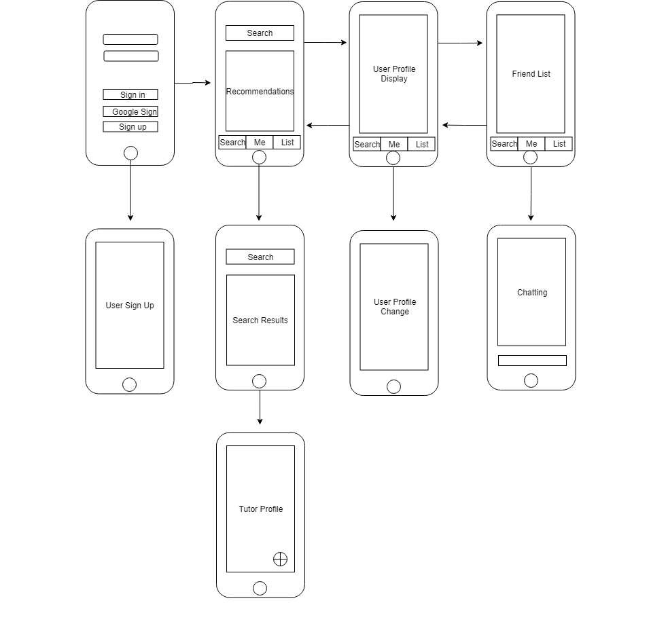
UI Goal

